# Aspiring Chief Executive Programme **Sponsorship Declaration Form**

## To be completed by the Chief Executive/Chair of employing organisation

# Aim

The Aspiring Chief Executive programme aims to assess and develop our next generation of chief executives to lead in an NHS accountable role focused on both service provision and system development within the next 12-24 months.

As a Chief Executive/Chair, you are asked to sponsor the application of one of your employees as detailed below. As sponsor, you will support the career aspiration and development of an individual as a patron, actively championing and supporting the individual.

Over a period of time, you will look for opportunities, and make connections to promote their further development and progression. In relation to this programme, by formally signing this declaration, you will:

|  |  |  |
| --- | --- | --- |
| Hold a career conversation with the applicant to confirm that they meet the eligibility criteria and demonstrate the **aspiration, agility and ability** for a chief executive role within 12 -24 months of completion of the programme. Further details and guidance are provided below.  **1** | Agree to support their development throughout the programme, release time for their development and champion their deployment into a chief executive role.  **2** | Complete the supporting information below, noting that we are unable to accept applications without this endorsement.  **3** |

|  |  |  |
| --- | --- | --- |
| Sponsor name | Click or tap here to enter text. | |
| Sponsor’s role | Click or tap here to enter text. | |
| Organisation | Click or tap here to enter text. | |
| Applicant name | Click or tap here to enter text. | |
| Applicant on your organisation’s succession plan? | YES/NO (If not, please explain why). | |
| Applicant role | Click or tap here to enter text. | |
| Applicant email | Click or tap here to enter text. | |
| Applicant band | Click or tap here to enter text. | |
| Career conversation held? | YES/NO | Date of conversation. |

## A short guide to holding an effective and engaging career conversation for the purpose of this programme is outlined below using the ‘Scope for Growth’ model.

### What is Scope for Growth?

Scope for Growth offers a consistent approach to inclusive and holistic career conversations to ensure greater visibility of the talent and aspirations of our people.

The Scope for Growth 3-step career conversation tool provides a simple, semi-structured framework to support career development conversations.

For this guide, the model has been adapted to help you discuss suitability for this programme by understanding an individual’s aspiration, agility and ability.

# Before you start

## Creating the conditions for a successful conversation

* Take a holistic, inclusive approach, acknowledging that one’s life outside of work may impact on their career.
* Enable the individual to reflect upon and take ownership of their career aspirations and journey.
* Be aware of your own personal biases.
* Ensure you agree a suitable time and place to meet and allow sufficient time for a meaningful conversation.
* Agree and record the outcome as part of a development plan and to enable completion of this sponsorship form.

Figure 1: NHS England   
3As Talent Identification Model

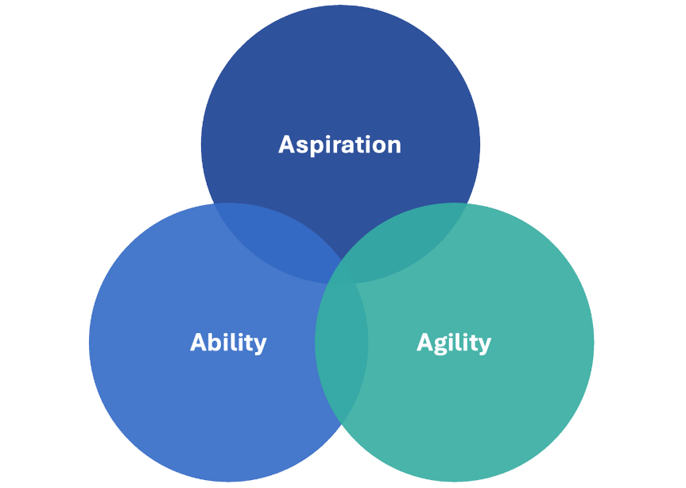

|  |
| --- |
| Step 1: **Agility**  Also described as potential and adaptability, this involves proactively seeking new situations to test and stretch one’s learning and adaptability.  Explore what matters to the individual, their key strengths and how they demonstrate the drivers, motivators and values that are aligned to those required for a chief executive role? |
| **For example:** They may have deputised for you as chief executive several times, including outside the organisation. They are able to demonstrate their leadership skills amidst changing conditions and high levels of ambiguity. They have influence and impact across the whole organisation, and in a wider context. Are they on the organisation’s succession plan? If not, what would it take to be on there? |
| A blue circle with white text  Description automatically generatedStep 2: **Aspiration**  Also described as ambition, this is the extent to which an individual is equipped and motivated to seek career growth opportunities with increased complexity, responsibility, and strategic decision-making.  Explore their current experience and how they are proactively increasing their understanding of, and capability for, the chief executive role? |
| **For example:** They want to do the role, they understand and have realistic expectations of what it involves. They are aware of their motivations and drivers and you each believe that they will thrive in the role. What additional exposure or work would help to increase their understanding? Do they have the support of the board? Where is their next move likely to be? How are they leveraging their relationships already and what else might help to increase their visibility or credibility with key stakeholder groups? |
| A blue circle with white text  Description automatically generatedStep 3: **Ability**  Also described as ethos and competence, this is a combination of knowledge, experience, learned skills and cognitive ability.  Explore what development do they need in order to be ready for a chief executive role. What is already in place to support this development? What timeframe do you consider is realistic to achieve readiness? |
| **For example:** They are a highly capable executive, who has worked effectively as part of a unitary board and across the wider system. They are aware of their strengths, potential derailers and gaps and consciously manage them. They have a breadth of experience at board level and the values and capability to lead the strategy of the organisation within the context of the wider system. The applicant can self-assess against the new [Board Leadership Competency Framework](https://www.england.nhs.uk/long-read/nhs-leadership-competency-framework-for-board-members/) which can be used to offer honest and constructive feedback that is balanced, developmental, de-biased and specific. |

### Using the Scope for Growth Model

Building on your discussion using the ‘3As’ above, you can use the Scope for Growth model (Figure 2 below) to provide further insight into suitability for the Aspiring Chief Executive programme.

* Scope for Growth is built around three categories: **depth, breadth, and stretch/complexity**. It also has an impact axis and a growth axis.
* The impact axis refers to an individual’s underlying capability, along with their contribution to their team, organisation, and wider stakeholders. Impact includes both what individuals do and how they do it, so performance in role will influence this axis.
* The growth axis refers to an individual’s personal ambition for growth across the three categories.

##### Depth

Focus on expanding   
expertise in their chosen profession or role.

##### Breadth

Focus on broadening out   
their career, from their organisation, or environment.

##### Stretch/Complexity

Focus on growing beyond their current role into areas of greater complexity and influence and increasing in leadership impact.

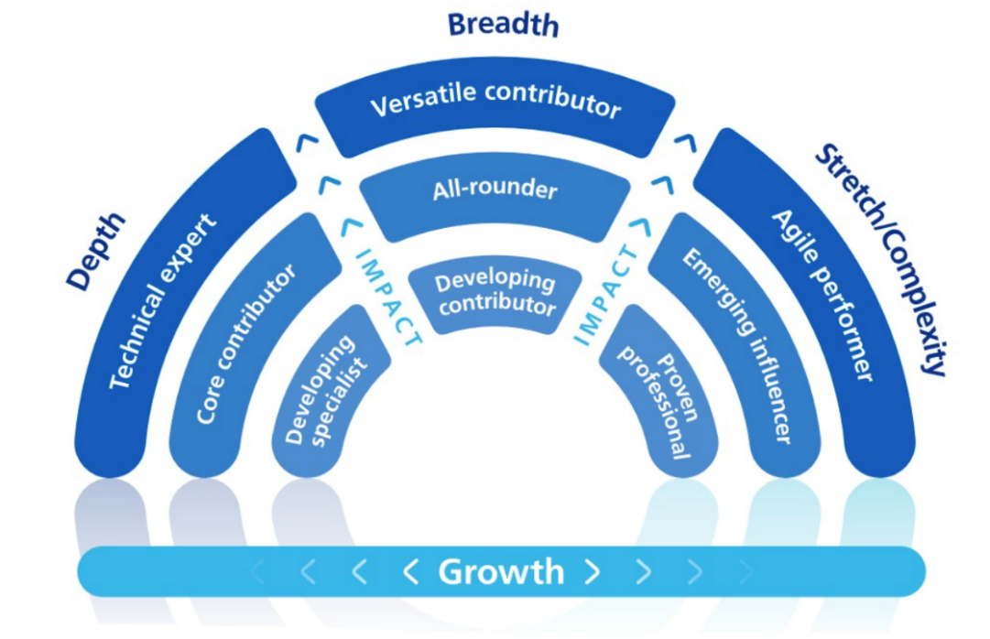

Figure 2: Scope for Growth Model

|  |  |  |
| --- | --- | --- |
| **Conversation outcome:**  Check applicable box | | **Next role aspiration:** *Please specify role and/or organisation type and is it internal or external to current organisation?* |
| **Depth** |  | Click or tap here to enter text. |
| **Breadth** |  |
| **Complexity** |  |

## Finally, please agree a personal development plan with short and longer-term goals. You could consider:

* Work based learning (secondments, stretch assignments, shadowing)
* Reflective approaches which offer insight (coaching, mentoring, action-learning)
* Formal development programmes such as the Aspiring Chief Executive programme.

Having completed a career conversation/‘Scope for Growth’ conversation, if you agree that the individual is suitable for the Aspiring Chief Executive programme, please complete the following information to support their application:

|  |  |  |
| --- | --- | --- |
| **Does the applicant meet the** [eligibility criteria?](https://www.leadershipacademy.nhs.uk/aspiring-chief-executive-programme-cohort-5-participant-criteria/) | | **Yes  No** |
| **What plans has the applicant put in place to ensure they are able to embed and reinforce their learning in their current role, and how will you support them?** | | |
| Maximum 250 words. | | |
| **What will the cohort gain from their participation?** | | |
| Maximum 100 words. | | |
| **Why do you think that this applicant is right for this programme and this programme is right for the applicant? For example, what additional learning are you hoping they will gain from the programme in preparation for their first chief executive role?** | | |
| Maximum 250 words. | | |
| **Declaration** | | |
| **I consent to this form being shared with relevant partners, including national and regional talent and leadership teams to enable bespoke talent development offers to be developed and offered.** | | **Yes  No** |
| By their signature on this form, the applicant’s chief executive/chair and therefore the employing organisation confirm that, should the applicant be successfully accepted onto the programme, they fully support the applicant to take part and agree to make the necessary work-place arrangements for the applicant to attend all the face-to-face elements and agree any study leave the applicant needs to complete the required study time. On average this would amount to ***one day a week for the nine months of the programme***. Additionally, the participant will be supported to apply their learning within the organisation.  As part of this programme, each participant may need to do some work for the executive team and board of the organisation of a fellow participant. The details of this work will be agreed with the chief executive and chair of the receiving trust and remain strictly confidential to that trust. We request your agreement in principle as the sponsoring organisation of a participant to collaborate with one of their fellow cohort members in this way.  The programme place is fully funded – this does not mean to say the programme is free. If, having accepted a place, the applicant either fails to start or fails to complete the programme for any reason other than for a reason that the NHS England, (in its absolute discretion) determines is an extenuating circumstance, the NHS organisation will pay the NHS England the sum of £10,000 as agreed recompense for subsidising the applicant’s place on the programme. | | |
| **Applicants signature:** | Click or tap here to enter text. | |
| **Sponsors (Chief Executive/Chair) signature:** | Click or tap here to enter text. | |